Directions: Use the primary and secondary sources provided to you in your document collection to determine one reason as to why European explorers began exploring the New World.

Remember what you should be looking for when analyzing sources and to connect your documents to one another!

Keep in mind these Essential Questions:

1. Be a historian! Examine your documents and describe them in detail. What are they and what do they discuss/depict (show)?

2. How are your documents related to one another? What do they all have in common?

3. Why did Europeans begin exploring the world in the 15th-18th centuries?

Group 1

Document A

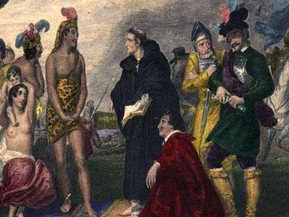

Document B

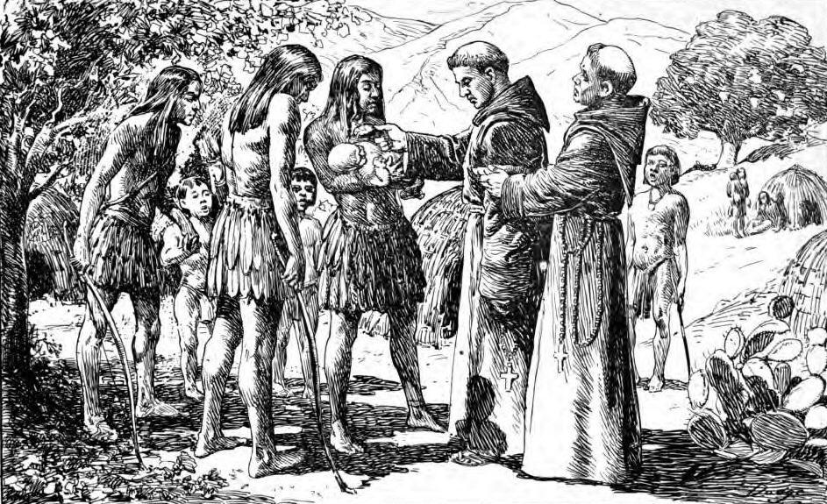

Document C

“In this large and very fertile vineyard of the Indian tribes, I have been able, with God’s help, to wash about three hundred Indians in the holy water of baptism…God willing, hundreds, and later, thousands will be gathered into the heart of our sweet, most holy, Mother Church… We are now in the process of building a new church…”

-Father Kino, Catholic Priest, 1687

Group 2

Document A

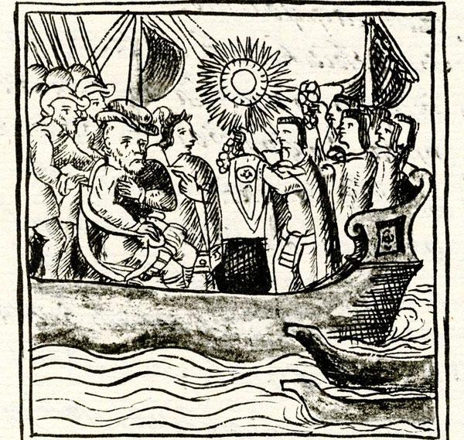

Document B

“Cortés also asked them where they procured [got] their gold and jewels, and they replied, from the direction of the setting sun, and said "Mexico".

“When the above had been done, [the Spaniards] attempted to find out about the special storehouse of the Aztec Emperor and he took them there." The Spaniards went along very joyfully, thinking that they would find much gold there; on arrival they took everything out of the Emperor’s storehouse, where there were many precious items of gold, silver, and precious stones, and they took it all. They removed all the gold and stones from the rich feather-pieces and put the feathers in the middle of the courtyard for their friends to take”

-Díaz del Castillo, “The Discovery and Conquest of Mexico, 1517-1521”, 1585.

Document C

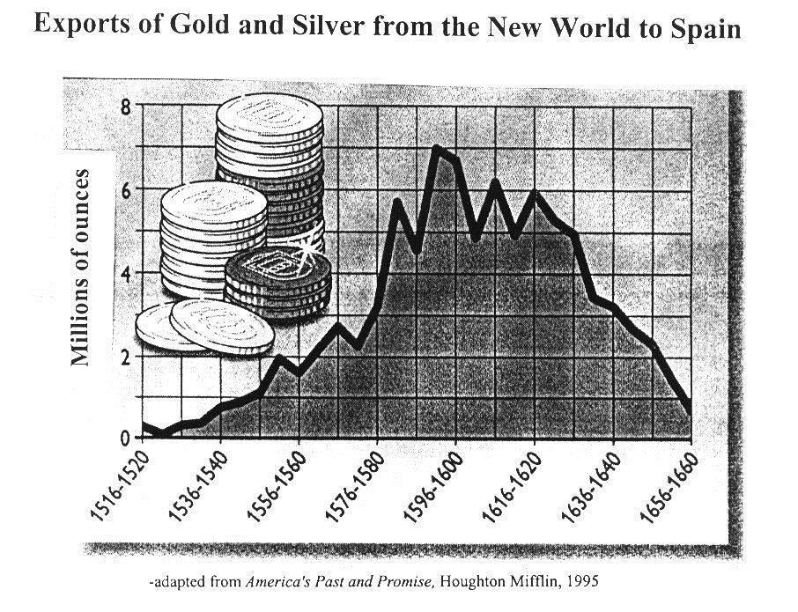

Group 3

Document A

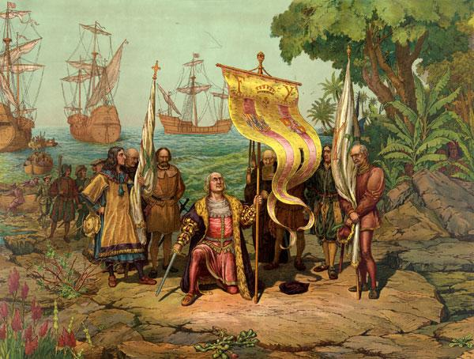
Artist rendition of Columbus reaching the New World

Document B
.
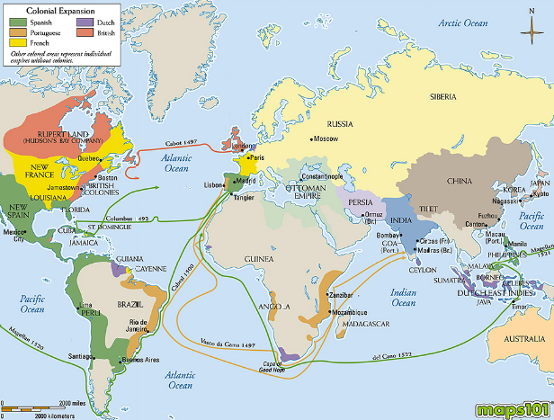

Document C

“In my youth I crossed the sea to the land of Peru to gain fame, lance in hand... In 24 years I have done you great service in Peru, in conquests of the Indians, in founding towns, and especially in battles and encounters fought in your name, always to the best of my power and ability, without requesting of your officials pay nor assistance, as can be seen in your royal records.”
-Lope de Aguirre, Spanish Conquistador (Conqueror) in a letter from to King Philip of Spain, 1561

